Experiment 4 Sampling theorem

Objective: To understand the sampling theorem
To appreciate the effect of aliasing and how it can be reduced

Background information
The advantages of digital signal processing outweigh those of analog signal processing. However, before a signal can be digitally processed by the digital computer or digital signal processor, it must first be sampled. The purpose of this experiment is to help you understand the sampling theorem and its implications. Nyquist stated that to reconstruct the original signal from its sampled form, the sampling frequency must be at least twice if not more, than the highest component of the signal. Aliasing occurs when the sampling frequency is less than twice the highest frequency component of the sampled signal. When this happens, the reconstructed signal will be distorted. Assuming that the sampling frequency is fixed, to eliminate the effect of aliasing, we need to condition or bandlimit the signal.

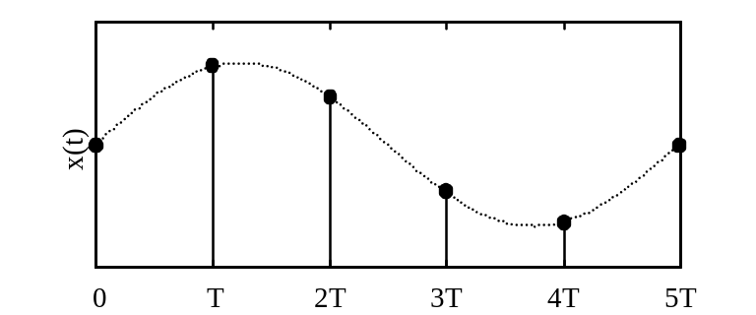
Figure 4–1 – Example of a sampled signal waveform

The signal, x(t), from the real world is often analog in nature. Before the signal can be processed digitally by a digital computer or digital signal processor, it must first be sampled by an analog-to-digital converter or ADC. Figure 4–1 show an example of a sampled signal waveform.

The ADC converts the analog signal, x(t), into a sampled signal, x(n), before passing them to the digital computer. The digital computer processes these data, x(n), from the ADC, at discrete time intervals, T. After processing, the processed data, y(n), is converted to its analog form, y(t), by the digital-to-analog converter or DAC. The three blocks in the center of Figure 4–2 show the flow of the various conversions.

Anti-
Aliasing
Filter
Sample
And
Hold

ADC
Digital
Signal
Processing

DAC
Reconstruction
Filter

x(t) x(n) y(n) y(t)
Figure 4–2 – A complete digital signal processing system
Usually, a fixed sampling frequency, f_{s}, is used in the ADC. To ensure that no aliasing occurs, the signal to the ADC must be bandlimited to half the sampling frequency. This bandlimiting is done using a low pass filter or often called an anti-aliasing filter with a cutoff at half the sampling frequency as shown in Figure 4–2. This maximum frequency, f_{s}/2, is called the Nyquist frequency. Hence, the analog signal must pass through the anti-aliasing filter to ideally attenuate to zero any signal frequencies above the Nyquist frequency. This is done even if the analog signal do not contain any components above the Nyquist frequency because any unwanted high frequency noise can cause aliasing errors in the sampled signal.

The effect of aliasing is best appreciated when analyzed in the frequency domain. It can be proven that the spectrum of the sampled signal is the summation of the original analog signal spectrum and its replications at intervals of f_{s}. Any spectral feature at +f_{o} will find itself repeated at 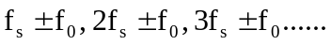 where f_{o} is the frequency of the signal to be sampled and f_{s} is the sampling frequency.

In this experiment, you will sample some real-time signals with a fixed sampling frequency at 1 kHz. You will observe the time domain and frequency domain characteristics of the signals using the MATLAB software. Having realized the effect of aliasing on the square wave signal for sampling frequency less than twice the signal frequency, an antialiasing filter is used to ensure that the highest frequency of the signal is less than half the sampling frequency.

Procedure 1: Sampling the sine wave (time domain)
- We will use Matlab to synthesize signals and simulate the effects of sampling. First we will generate a 1 kHz sine wave sampled with 8 kHz sampling frequency and plot the first 30 samples.

>>n=0:1000;
>>fs=8000;
>>sin8000=sin(2*pi*1000*n/fs);
>>stem(n(1:30),sin8000(1:30),’filled’);

Record the results.

Record the number of samples for one cycle of fs=8000 Hz in Table 4–1 and sketch the plot in Error: Reference source not found(a). Repeat for fs=4000Hz.

8 | Sampling Freq (Hz) | No. of samples per cycle
sin8000 | 8000 | 8
sin4000 | 4000 | 4
Table 4–1

Figure 4–3 – Plot of sampled sine wave in the time domain

(a) – Plot of sin8000 |  | (b) – Plot of sin4000

Procedure 2: Sampling the sine wave (frequency domain)
- For the next part of the experiment, the characteristic of the sampled signal is seen in the frequency domain. To observe the sampled 1000 Hz signal using sampling frequency, 8 kHz:

>>clear;
>> n=0:9999;
>> fs=8000;
>> x=sin(2*pi*1000*n/fs);
>> spectplot(x,fs)

Sketch the spectrum and named it, Figure 4-4(a).

- Repeat for sampling frequency of 4000 Hz, 2000 Hz, 1000 Hz and 1100Hz and sketch the spectra in Error: Reference source not found(b) to (e):

>>spectplot(sin4000,fs);
>>spectplot(sin2000,fs);
>>spectplot(sin1000,fs);
>>spectplot(sin1100,fs);

- What conclusions can you draw from the plots of Error: Reference source not found?

Procedure 3: Effect of Aliasing

- The effect of aliasing of a sampled sine wave may not be so obvious. Instead of using a sine wave, which is single frequency in nature, we shall use a square wave signal of 30 Hz and sampled by 10kHz. As you already know, the square wave can be decomposed into the first fundamental frequency and its harmonics. For a perfect square wave, its spectrum only consists of odd harmonics.

>> t = 0:1/1e3:1;
>> y = square(2*pi*30*t,50);
>> fs=10000;

- Now, view the frequency spectrum of the 300 Hz square wave signal:

>>spectplot(y,fs);

How many non-zero components in the spectrum can you observe? Are these components the harmonics of the square wave? If not, what are they?

Try sampling frequency, 1000 Hz.

How many non-zero components can you observe? Are these components the harmonics of the square wave? Many

_____________________________________________________________________

Procedure 4: To see the effects of aliasing

- Aliasing occurs because the sampling frequency is below twice the highest frequency of the signal. To avoid aliasing, the signal frequency needs to be bandlimited by an antialiasing filter.

Discrete signal, ‘y2’ consist of two cosine waves at 200 Hz and 800 Hz, sampled at 8 kHz. Type the following Matlab commands and see the sampled frequency spectrum.
Is there any aliasing?

>> n=0:999;
>> fs=8000;
>> y2=cos(2*pi*200*n/fs)+cos(2*pi*1000*n/fs);
>> spectplot(y2,fs)

Change the frequency, fs to 1600 Hz using the following Matlab codes. Is there any aliasing? Explain.

>> fs=1600;
>> y2=cos(2*pi*200*n/fs)+cos(2*pi*1000*n/fs);
>> spectplot(y2,fs)

